
ACTIVITY REPORT
On

THE ART OF ENCRYPTION
- Name of the Department : BMSCE ACM STUDENT CHAPTER
- Name of the Activity: The Art of Encryption
- Objectives - “The Art of Encryption” was a poster design event with the theme "Secure Our World," held on account of the cybersecurity month aiming to raise cyber security awareness through a creative outlet. The event aimed to provide a platform for participants to showcase their creativity and designing skills through poster making.
- Date, Time, Venue of the Activity – The event took place in October 2024, running through the month and the event was conducted online.
Topic | Art of Encryption
Date/Day | October, 2024
Venue | ONLINE

- Summary of the Program - "The Art of Encryption" was a poster-making competition held during Cyber Security Month by the BMSCE ACM Student Chapter with the theme "Secure Our World." The event encouraged students to creatively depict cybersecurity themes, raising awareness about digital safety through art.
The participants were given a month to design posters on the given theme. Various specifications like putting BMSCE and BMSCE ACM Student Chapter logos were specified and the posters were told to be submitted to the specified mail.various guidelines were given like the format, size, etc were given. The posters were judged based on relevance to theme, creativity, quality of design and clarity of message.
From the mail the posters were judged and the 2 best posters were chosen based on relevance to theme and creativity. The winners were given a total prize pool of Rs.1500/-.
- Outcomes - The event garnered tremendous success with the participation of 24 contestants. Participants not only showcased their poster making skills but also demonstrated creativity. The event helped increase awareness among participants about the importance of cybersecurity and digital safety.
- Number of participants - The event had a total of 24 participants.
Number of Faculty | Number of  Non-Teaching Staff | Number of  External Participants | Number of Students
0 | 0 | 3 | 24

- Photographs of the event




Supporting Documents
a. Circulars/Brochures
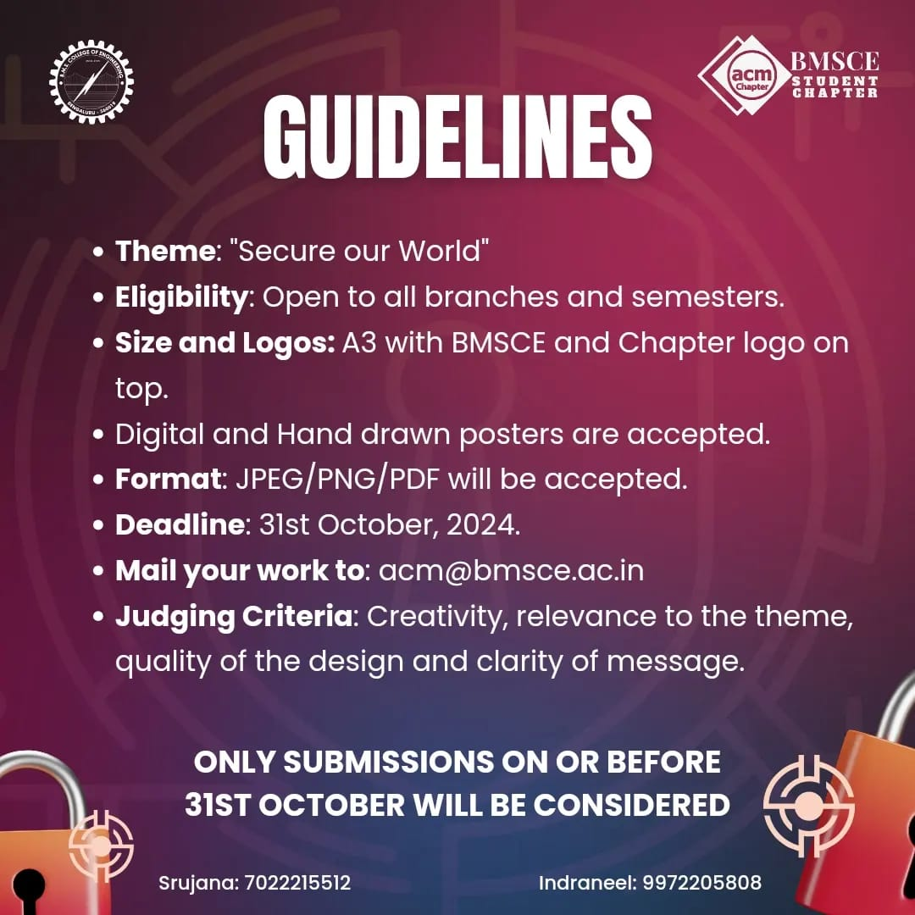
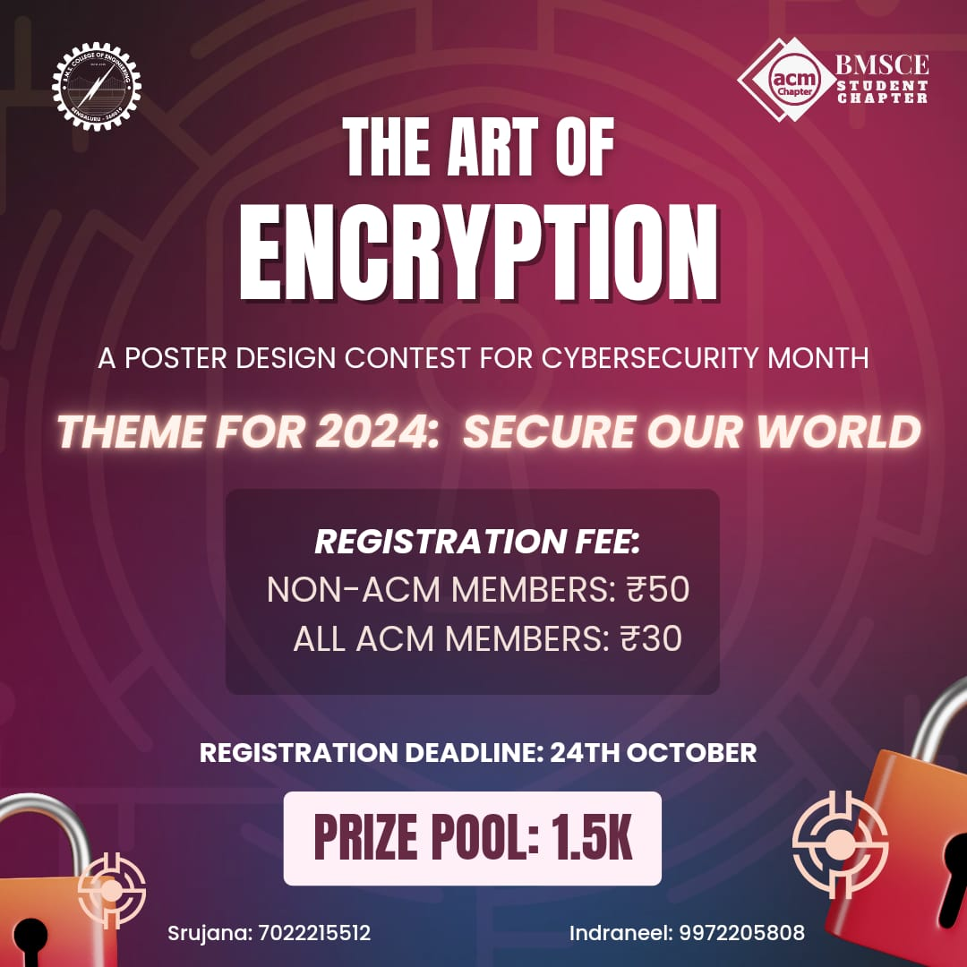
b. Certificates
